Compare and Contrast Linear and Binary Search

Binary search has a Big-O time complexity of O(log n). Whilst linear search has a Big-O time complexity of O(n). This means that for larger lists, binary search becomes more efficient in comparison to linear search.

However, it’s important to note that binary search only works when the list is already sorted. If the list is unsorted, then it first needs to be sorted, before it can be searched. Quick sort, one of the more time-effective sorting methods is O(n log n). Thus, for an unsorted list and for a single search, linear search would be faster.

Linear Search = O(n)

Quick sort + Binary Search = O(n log n) + O(log n) = O(n log n)
Worst case= O(n²)

If the intention is to search for multiple entities in a list, then binary search, combined with Quick Sort, could be more efficient:
If you search x times:
Linear search = O(xn)
Sort once + x binary search = O(n log n + x log n)

As such, the greater the number of searches required and the larger the entries in the list, the more time effective quick sort combined with binary search is in comparison to linear search.

To test this theory I compared 3 scripts (https://github.com/felttipfaerie/Launch-Into-Computing/tree/master/coursework/binary_search) and plotted the time it took to search increasingly large lists.

array size | binary search bisect | binary search iterative | Linear Search
100 | 18.8 | 6.3 | 11.5
1000 | 2.1 | 5.2 | 13.5
10000 | 1.7 | 2.1 | 119
100000 | 1.6 | 3.8 | 1300.9
1000000 | 9 | 7.8 | 11922.1

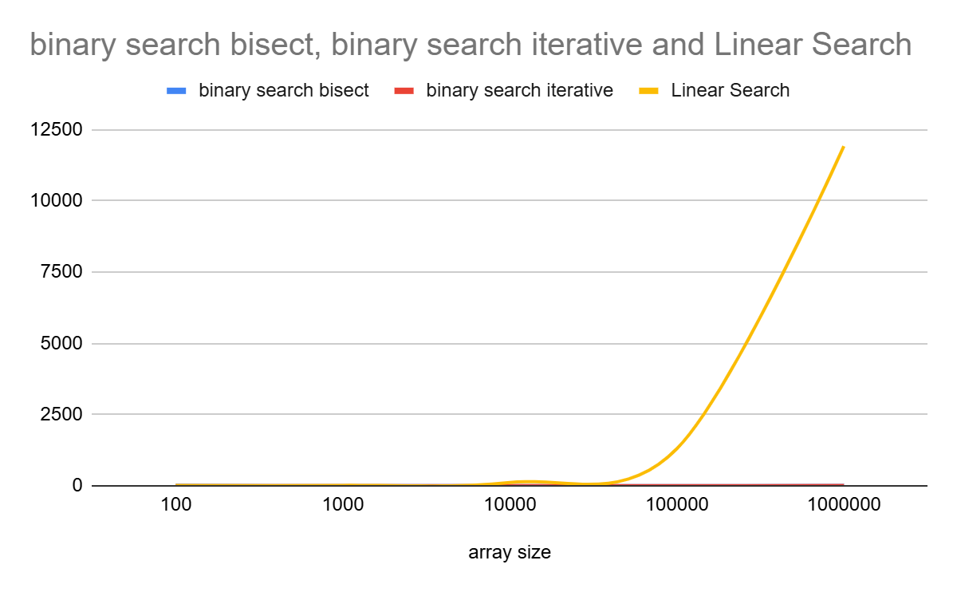

Although it’s interesting to note that the two different ways of coding the binary search resulted in different performances, the impact was insignificant to that of linear search.

